TASK 3 --- Application Deployment Process

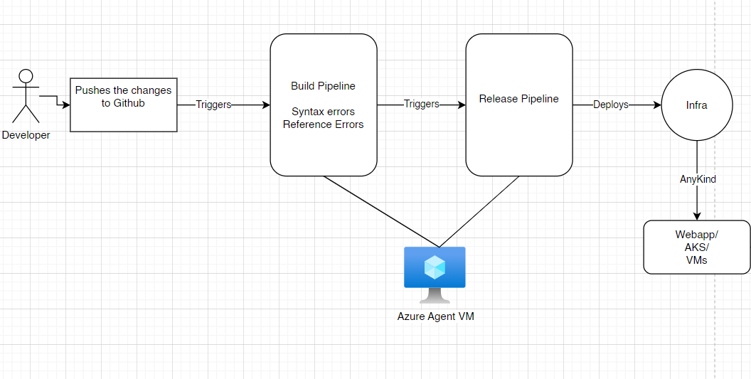

|  |  |  |
| --- | --- | --- |
| **Step** | **Task Description** | **Reference Link** |
| 1 | Create a simple .NET application (as in Task 1) | - |
| 2 | Upload the application code to GitHub | - |
| 3 | Generate a Personal Access Token on GitHub and save it | https://www.youtube.com/watch?v=toFrROIhUHM |
| 4 | Create Azure and Azure DevOps accounts | [YouTube Video](https://www.youtube.com/watch?v=hrBNBUZ6WWg) |
| 5 | Create an Organization and Project in Azure DevOps | [YouTube Video](https://www.youtube.com/watch?v=DV3V2leThxs&list=PLekDeiDz8-P3E_xRB961pkTrekHFR_f77) |
| 6 | Register App & get Client Id and Client Secret on Azure | [YouTube Video](https://www.youtube.com/watch?v=Oh90VbMrOVk) |
| 7 | Create a Service Connection between Azure and Azure DevOps | [YouTube Video](https://www.youtube.com/watch?v=06wxMtSt_0g) |
| 8 | Create an Azure Self-Hosted Agent | [YouTube Video](https://www.youtube.com/watch?v=jw6bWA3cds8&list=PLekDeiDz8-P3E_xRB961pkTrekHFR_f77&index=3) |
| 9 | Create a simple web app on Azure | [YouTube Video](https://www.youtube.com/watch?v=mpd6qEy4cEs) |
| 10.1 | Create a Build Pipeline in Azure DevOps for .NET application | [YouTube Video](https://www.youtube.com/watch?v=l_Bkk90umv4&list=PLekDeiDz8-P3E_xRB961pkTrekHFR_f77&index=4) |
| 10.2 | Create a Release Pipeline in Azure DevOps for deployment | [YouTube Video](https://www.youtube.com/watch?v=5cFkR-PYJjM&list=PLekDeiDz8-P3E_xRB961pkTrekHFR_f77&index=6) |